**Claim Tab**

To Include Cancel Status / Reopened Status

This Claim # is auto-generated when General Claim # is generated

Claim - ########

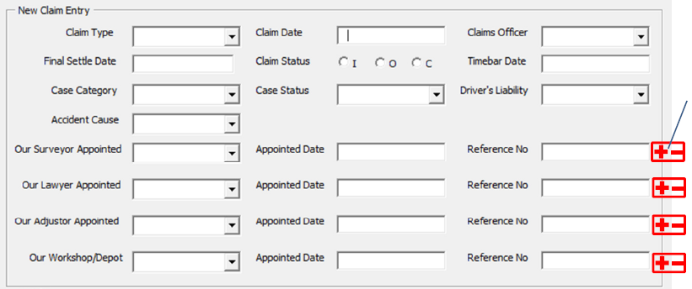

**Third Party Service Providers**

|  |  |  |  |  |
| --- | --- | --- | --- | --- |
| **S/No** | **Type** | **###** | **###** | **###** |
| **1** | **Claimant** |  |  |  |
| **2** | **Insurer** |  |  |  |
| **3** | **Workshop** |  |  |  |

System will save and display entries when user clicks on save. This Section is independent from the rest of the screen.

Insert New

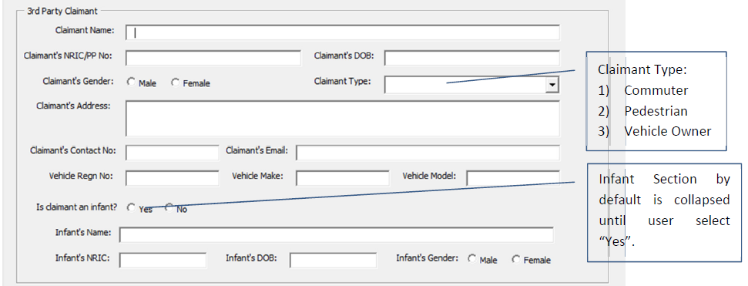

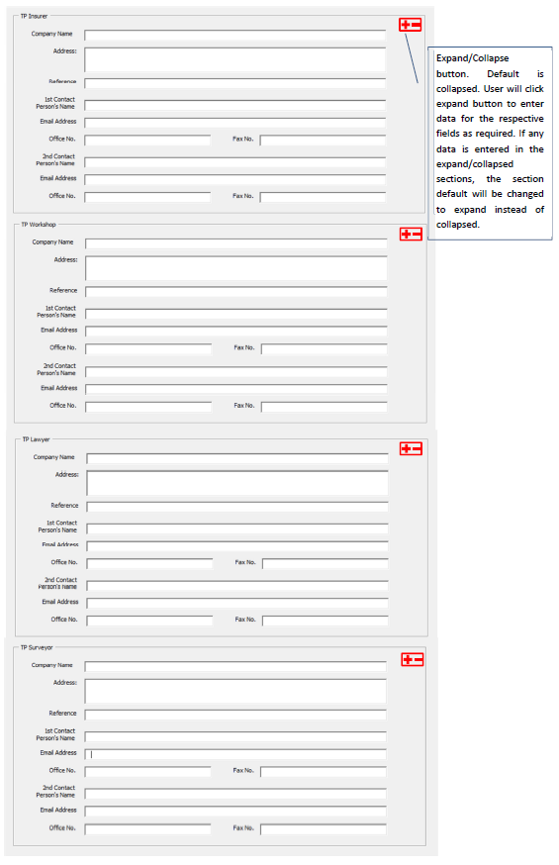**Initial Reserve**

Save

**Claim#2.png**

Add New

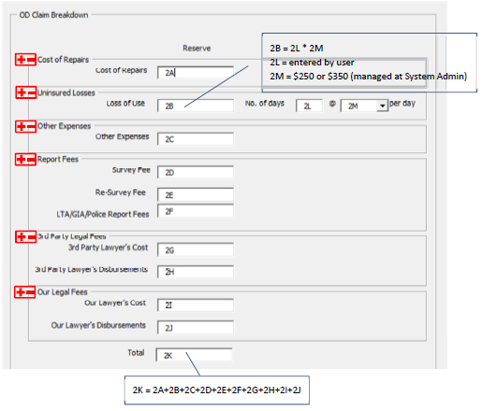

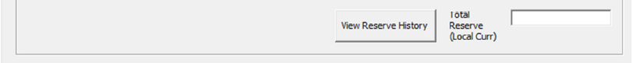

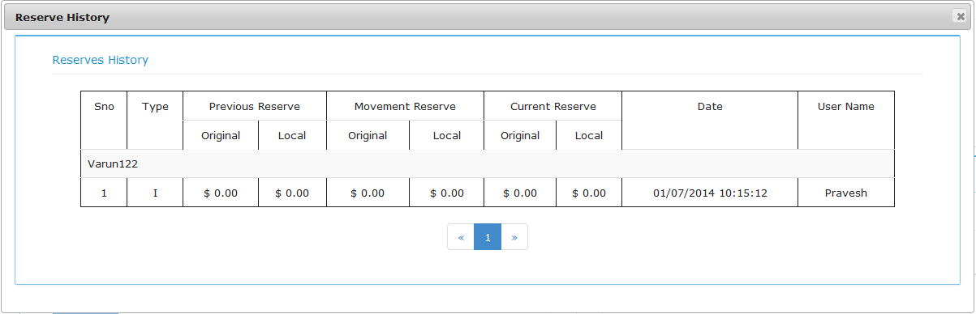

OD

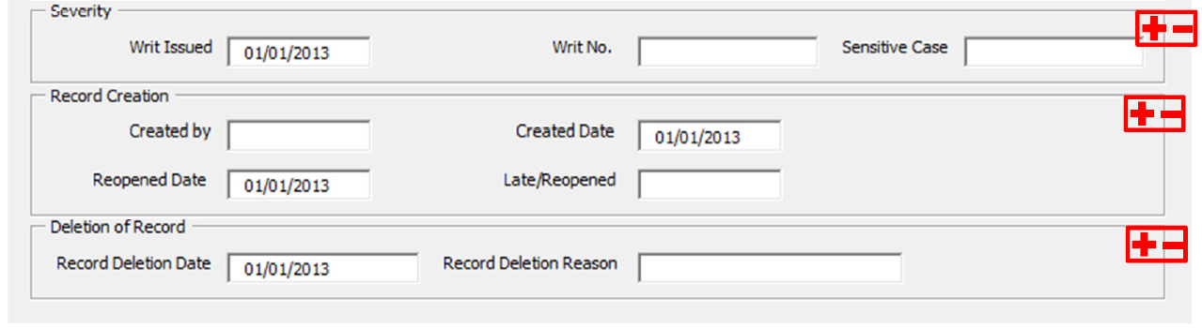

Reset

Save

Fields will open up when User select the options -- Cancelled / Re-opened

**Third Party Tab – Renamed To PD / BI Tab**

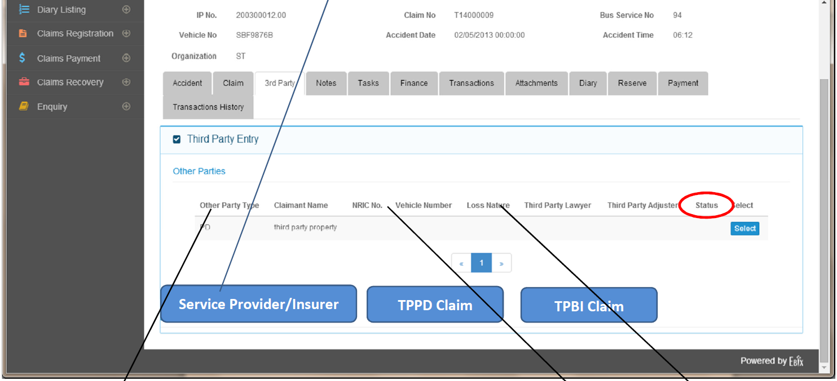

Number is generated when Button is Clicked

|  |  |  |  |  |  |  |  |
| --- | --- | --- | --- | --- | --- | --- | --- |
| **TP/No** | **Type** |  |  |  |  |  |  |
| **1.1** | **TPPD** |  |  |  |  |  |  |
| **1.2** | **TPBI** |  |  |  |  |  |  |

To Include Cancel Status / Reopened Status

**When Clicked….**

TP - ########



**Third Party Service Providers**

|  |  |  |  |  |
| --- | --- | --- | --- | --- |
| **S/No** | **Type** | **###** | **###** | **###** |
| **1** | **Claimant** |  |  |  |
| **2** | **Insurer** |  |  |  |
| **3** | **Workshop** |  |  |  |

Insert New (POPUP)

System will save and display entries when user clicks on save. This Section is independent from the rest of the screen.



**Initial Reserve**

Save

**Claim#2.png**

Add New

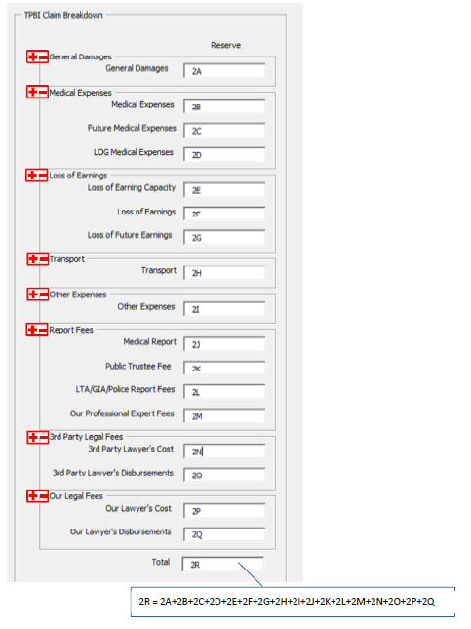





TPBI

TPPD

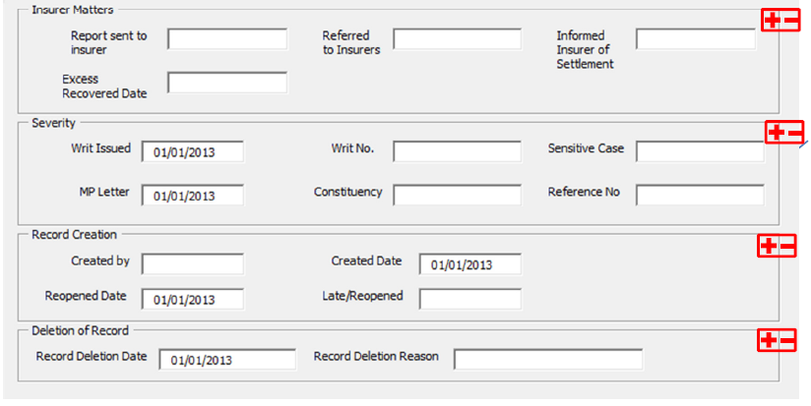

Fields will open up when User select the options -- Cancelled / Re-opened

Reset

Save